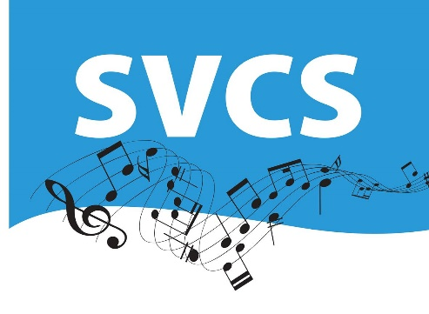

Subscriptions 2023/24

The annual membership subscription is currently £120 per annum. If possible, please pay by bank transfer to Sutton Valence Choral Society Sort Code: 53-81-51 Account: 01938088.
If you prefer, you can pay termly in which case the amount is £50, £50, and £20 per term.
Alternatively, you can pay by monthly standing order. Please ask Andrw Hutchinson, our Treasurer, for further details.
Subscriptions should be paid promptly and in any event before the fourth rehearsal of the year (or term if paying termly).
If you pay income tax, you can help choir funds by signing a Gift Aid form so that basic rate tax can be reclaimed on part of your subscription.

